Cluster-type: cluster_qm
max-pending-packets: 65534
stream.memcap: 4Gb
reassembly.memcap: 12Gb
depth: 1mb

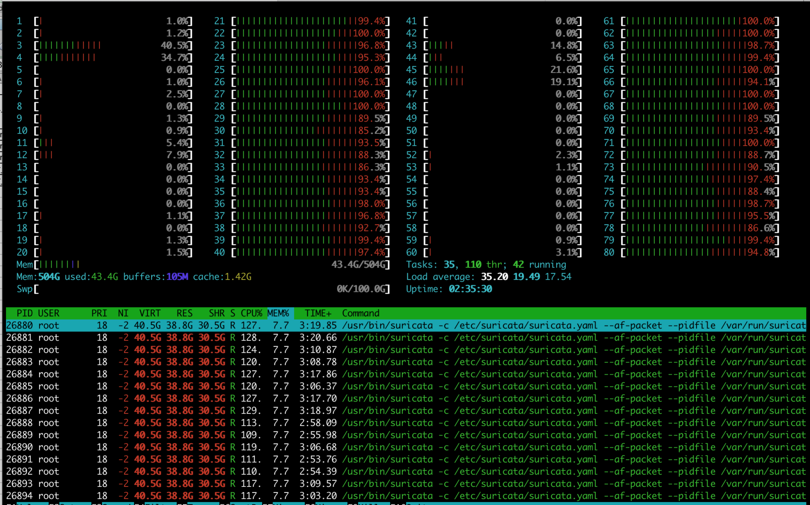
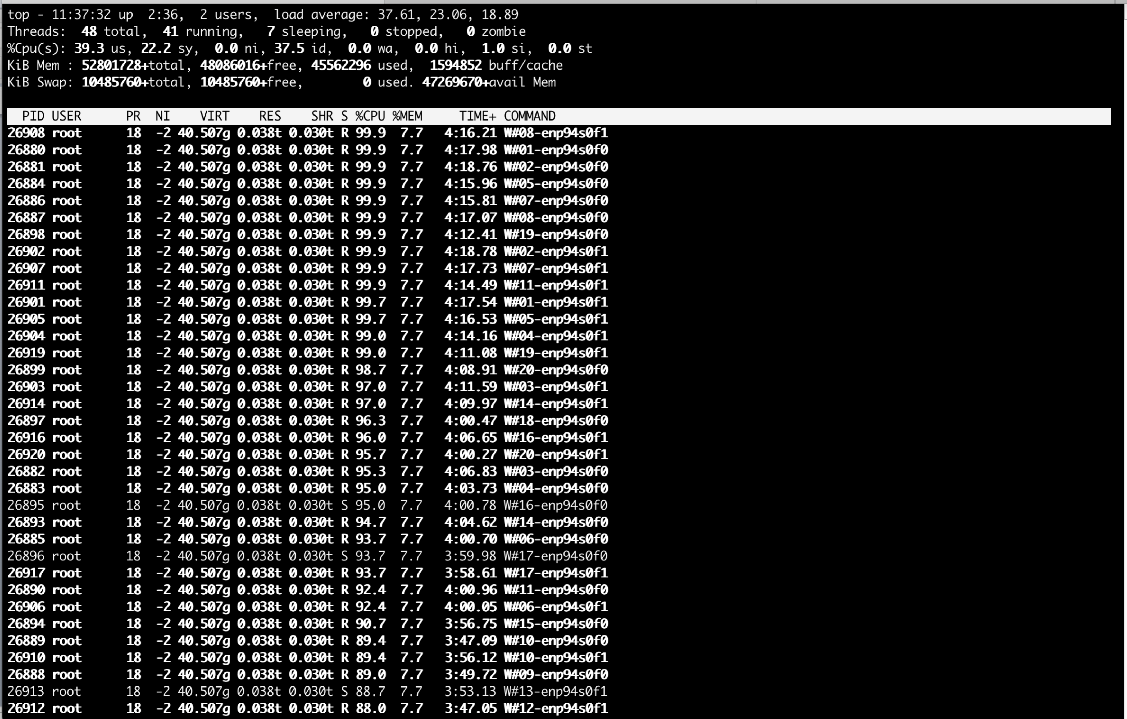
Cluster-type: cluster_qm
max-pending-packets: 65534
stream.memcap: 1Gb
reassembly.memcap: 2Gb
depth: 1mb

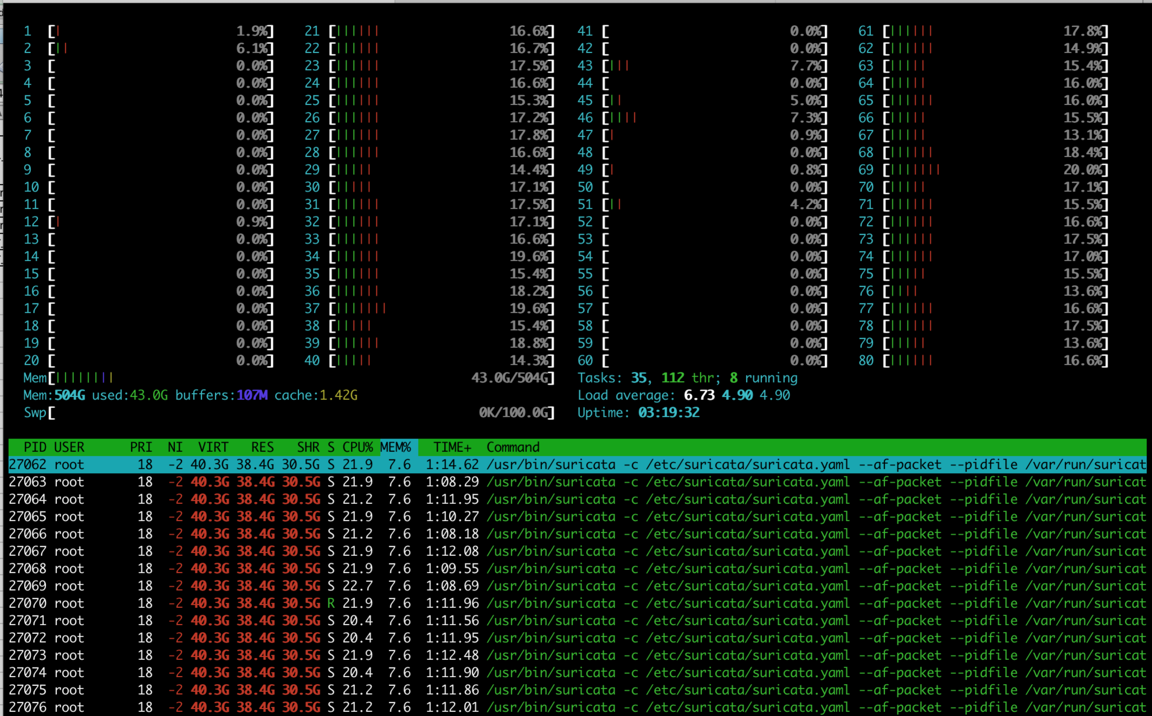
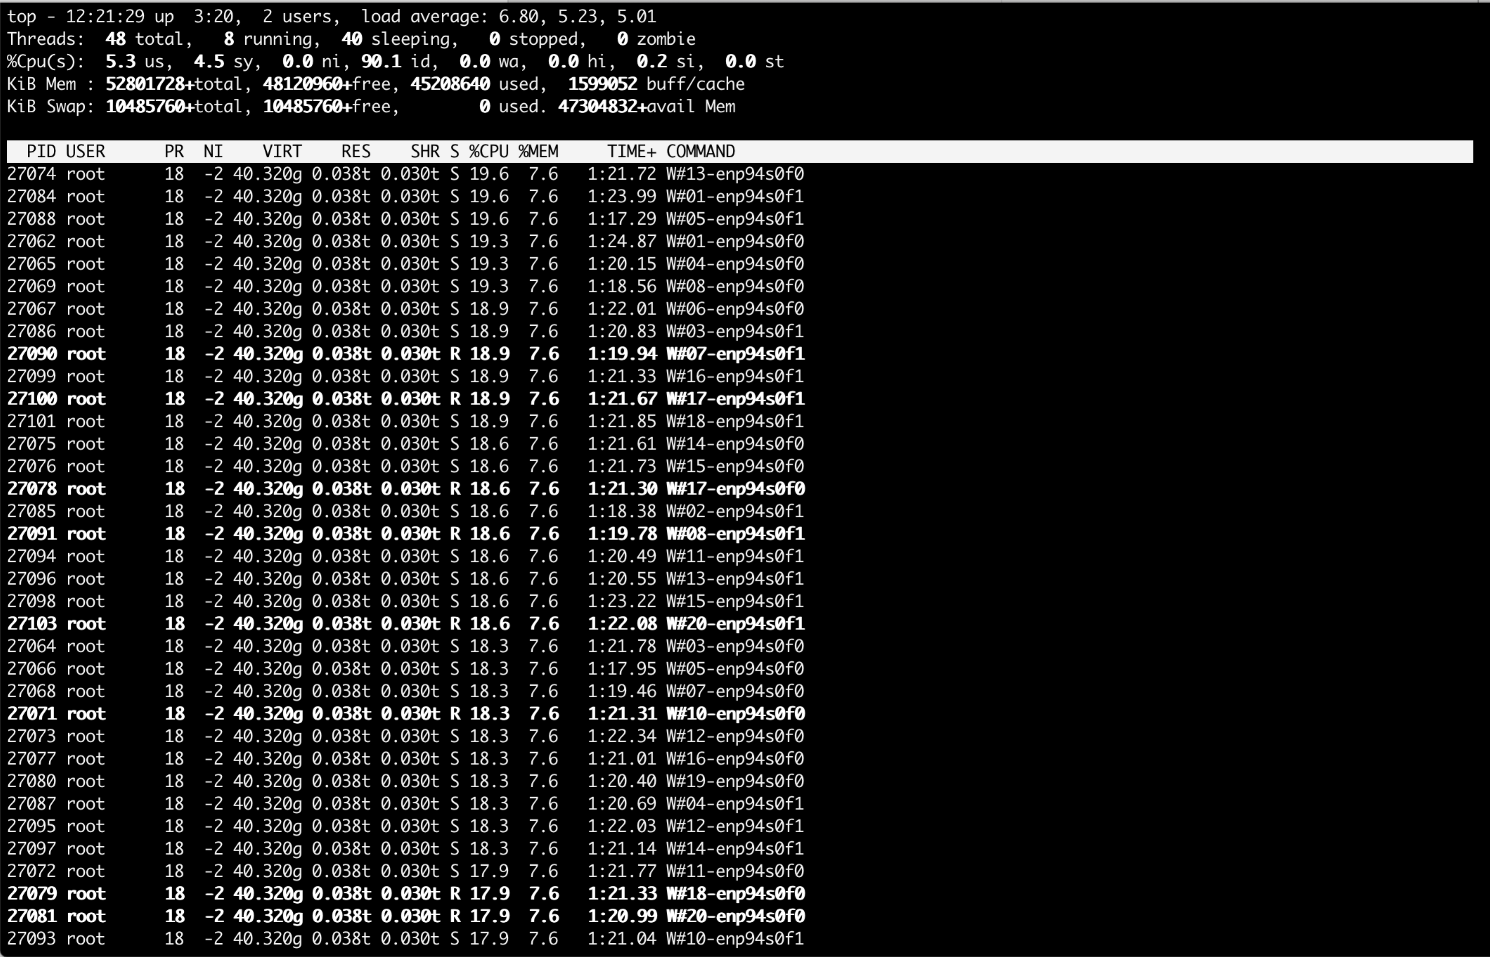
Cluster-type: cluster_qm
max-pending-packets: 1024
stream.memcap: 1Gb
reassembly.memcap: 2Gb
depth: 1mb

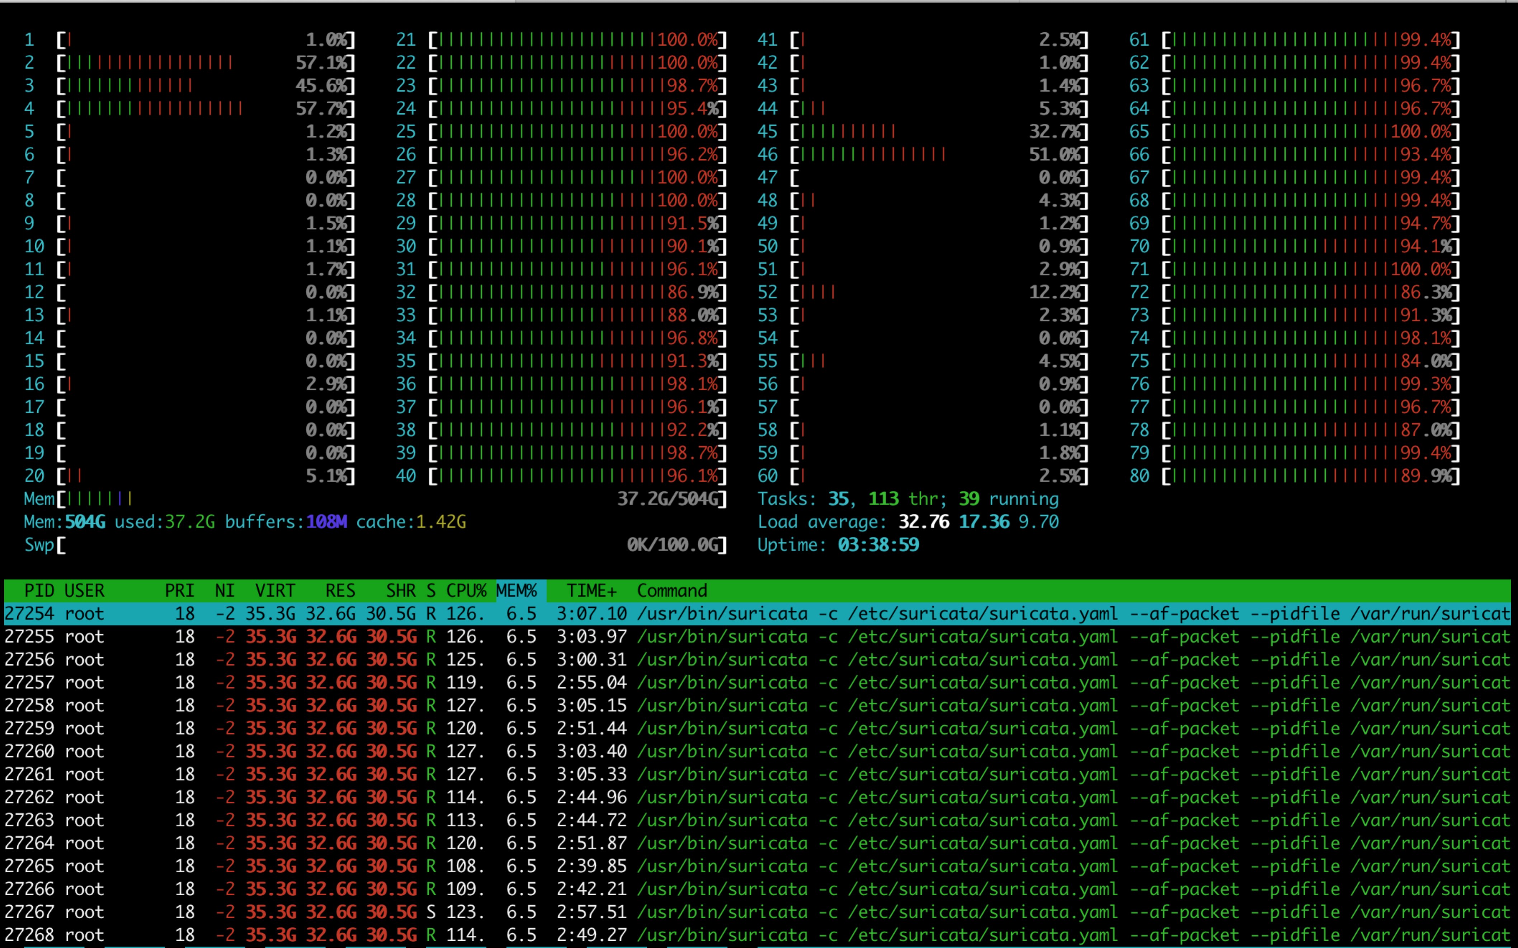
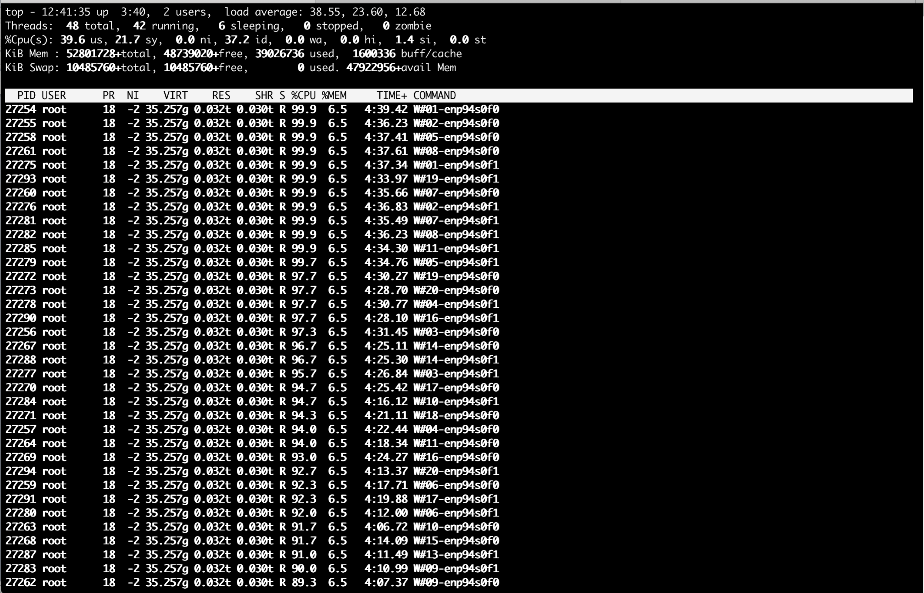
Cluster-type: cluster_flow
max-pending-packets: 65534
stream.memcap: 4Gb
reassembly.memcap: 12Gb
depth: 1mb

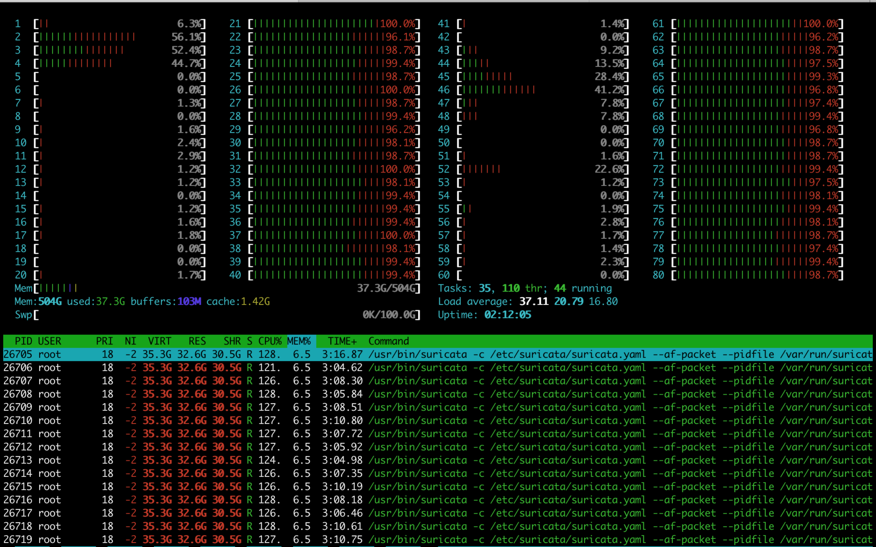
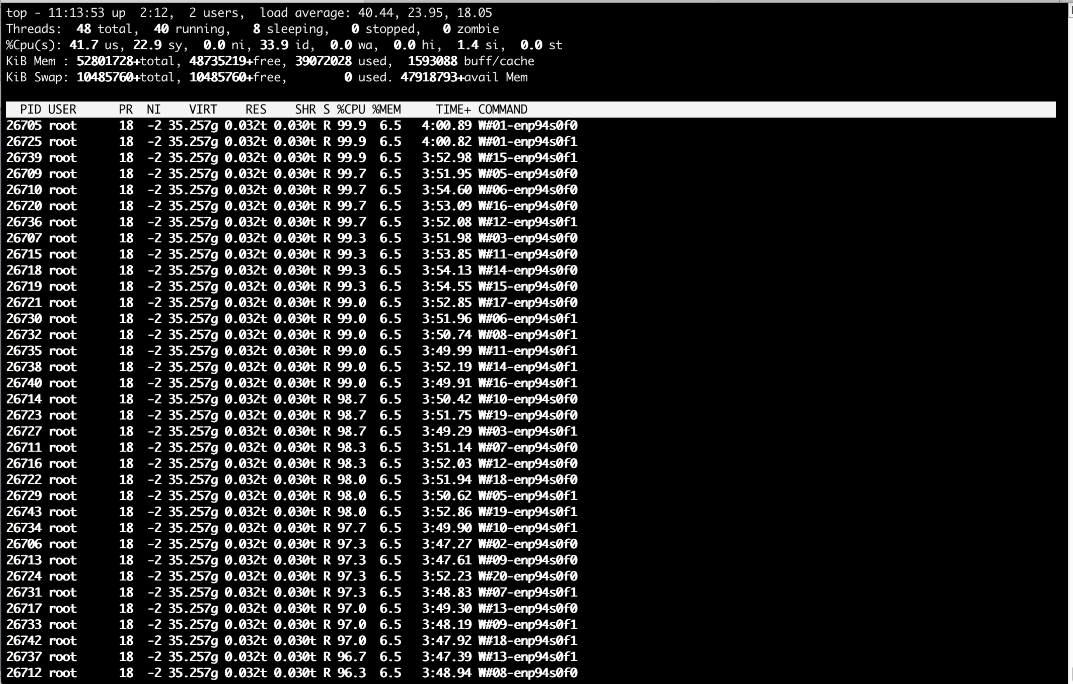
Cluster-type: cluster_flow
max-pending-packets: 1024
stream.memcap: 1Gb
reassembly.memcap: 2Gb
depth: 1mb


